­ClubUML: Walk-Through of Spring 2014 Contributions

Author(s): Xiang Cheng, Vishal Patel

Draft 1 (4/13/2014)

**Navigation**

1) Tabs to Navigate in and out of various pieces of the ClubUML project.

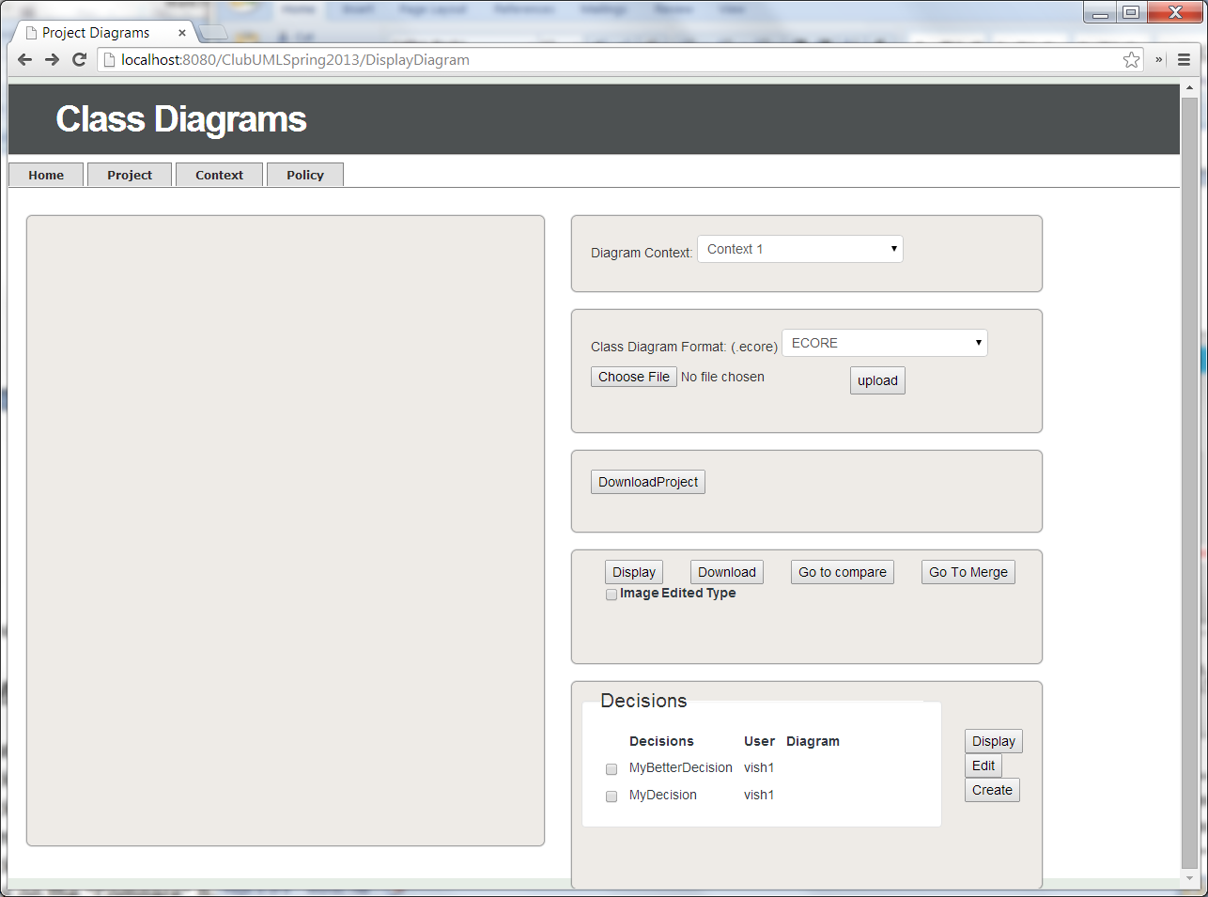

2) Add Context Page allows you to get back Home. [New Home button added on Bottom Left]

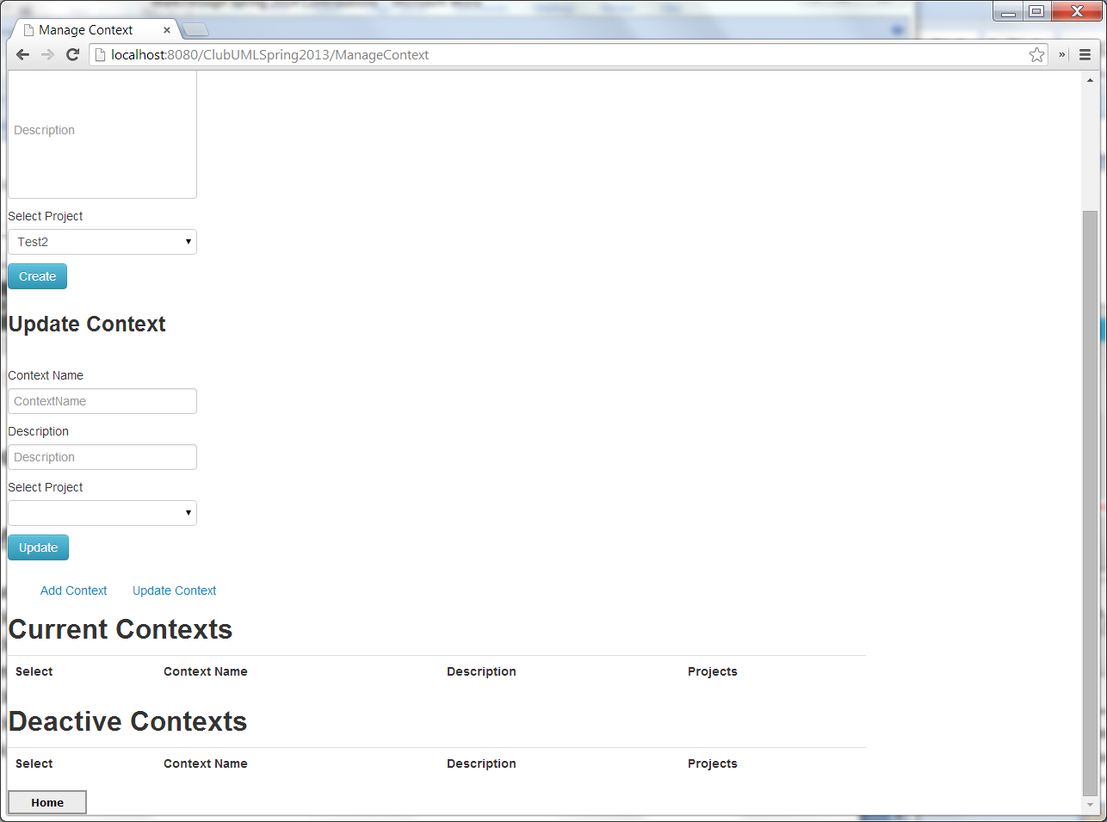

**Rationale Management**

1) Creating Rationale for a Diagram

a) Click on the "Projects" tab

b) Click on a particular project name.

c) Select two diagrams to compare

d) Click on the "Go to compare" button

e) Click on the "Compare" button

f) Click on the "Promote" button for the diagram you wish to promote and add rationale to

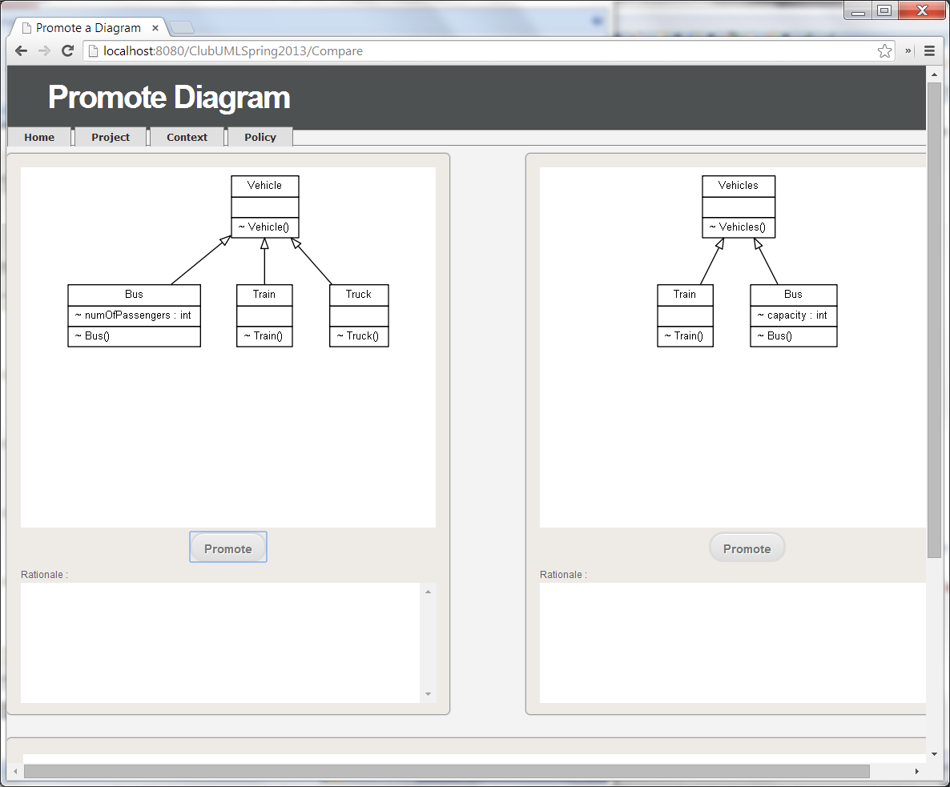

g) Enter the rationale info into the text boxes

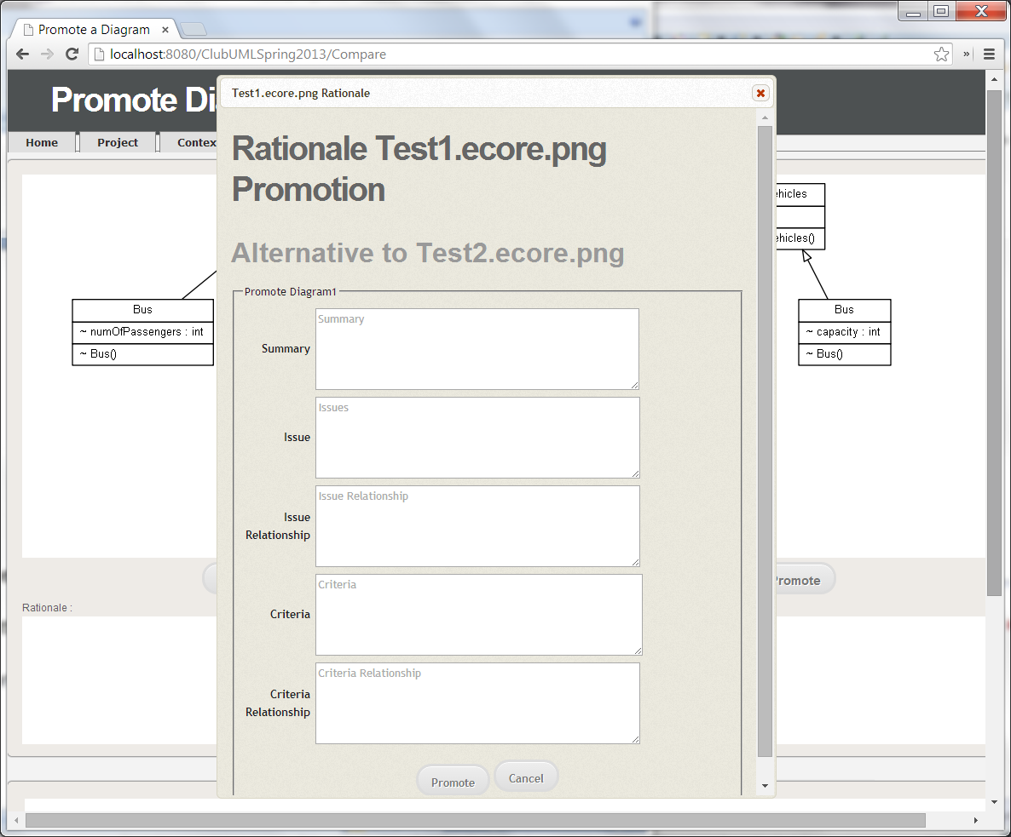

h) Click on the "Promote" button

2) Displaying Rationales for a Diagram

a) Click on the "Projects" tab

b) Click on a particular project name.

c) Select two diagrams to compare

d) Click on the "Go to compare" button

e) Click on the "Compare" button [At this point, all the Rationale for a particular diagram are displayed below the diagram]

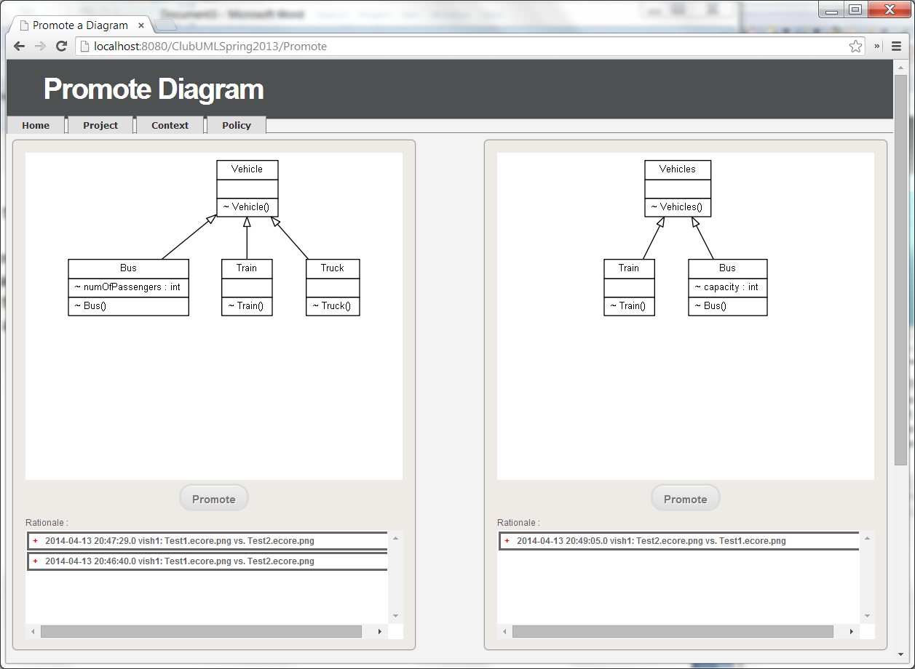

3) Displaying a Specific Rationale for a Diagram

a) Steps from #2 (Displaying Rationales for a Diagram)

b) Click on the Red + (Plus Sign) for the specific rationale desired. [At this point, the information will be expanded and displayed.] Clicking on the Red - (Minus Sign) will collapse the information.

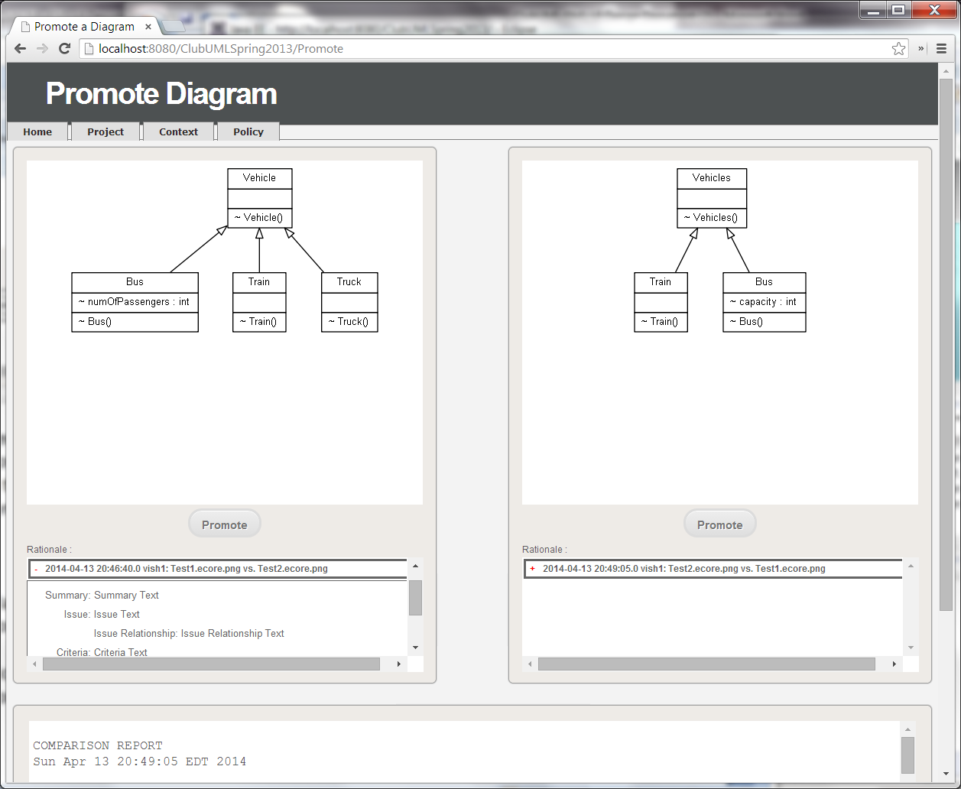

4) Edit a Specific Rationale for a Diagram

a) Steps from #3 (Displaying a Specific Rationale for a Diagram)

b) Click on the Pencil Icon, which will display the previous Rationale Info in the text boxes to be edited again.

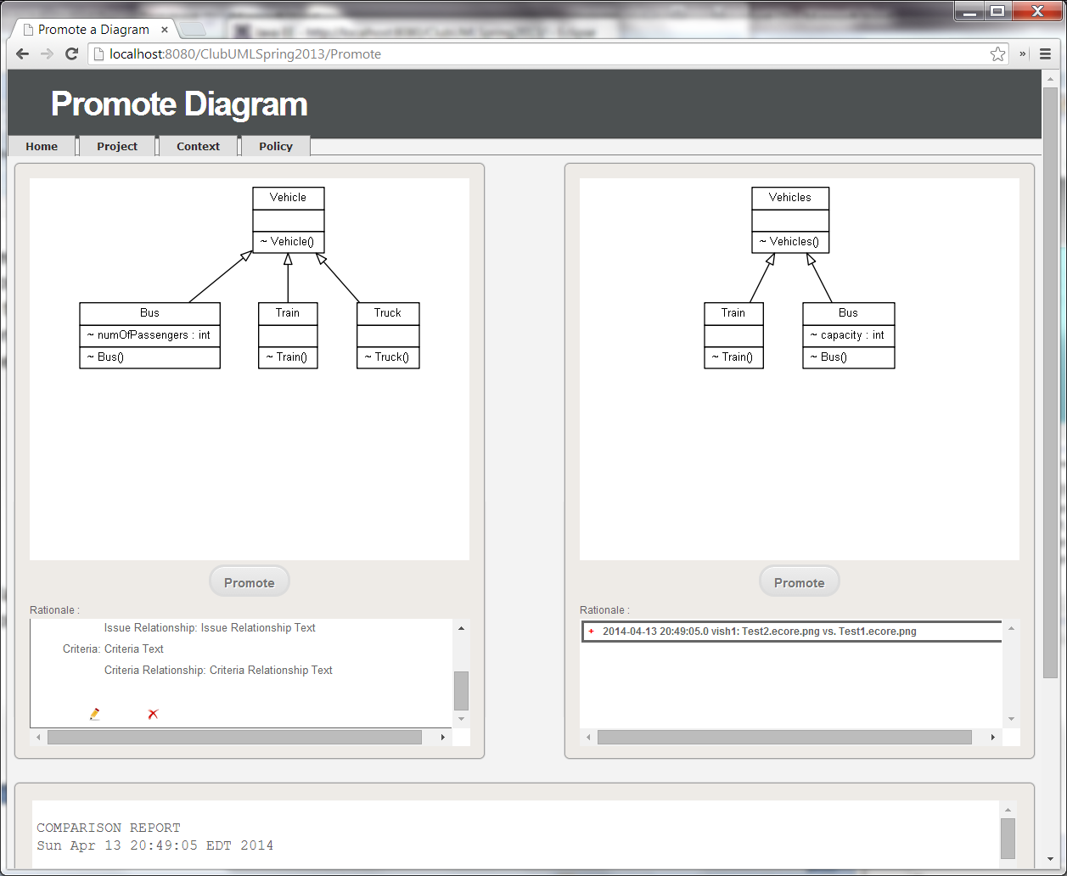

c) Click on the "Promote" button.

5) Delete a Specific Rationale for a Diagram

a) Steps from #3 (Displaying a Specific Rationale for a Diagram)

b) Click on the X Icon



c) A confirmation dialog box will appear, "Are you sure you want to delete?"

d) Click "OK."

6) Creating Decision

a) Click on the "Projects" tab

b) Click on a particular project name.

c) Click on the "Create" button on the bottom right portion of the page also the "Decisions" sub-section

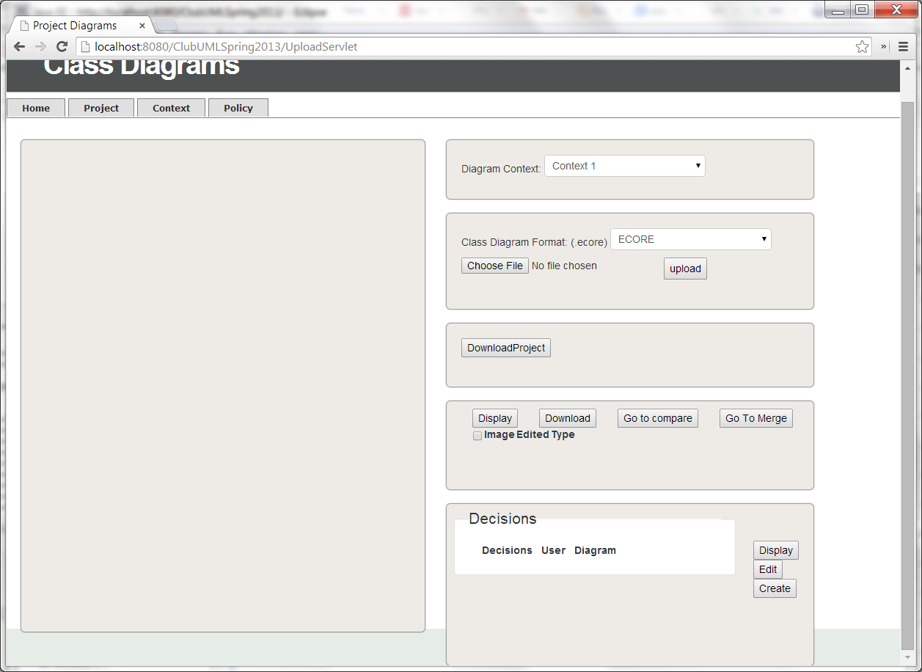

d) Enter a decision name in the text box.

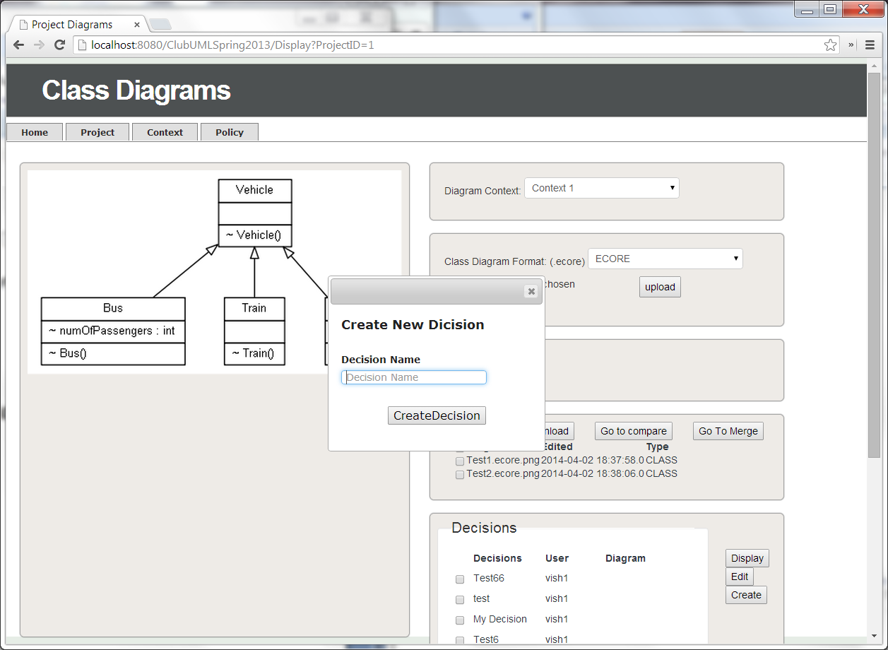

e) Click on "CreateDecision"

7) Displaying Decisions

a) Click on the "Projects" tab

b) Click on a particular project name. [At this point, the bottom right portion, also the "Decisions" sub-section will displayed all the relevant Decisions associated with the project.]

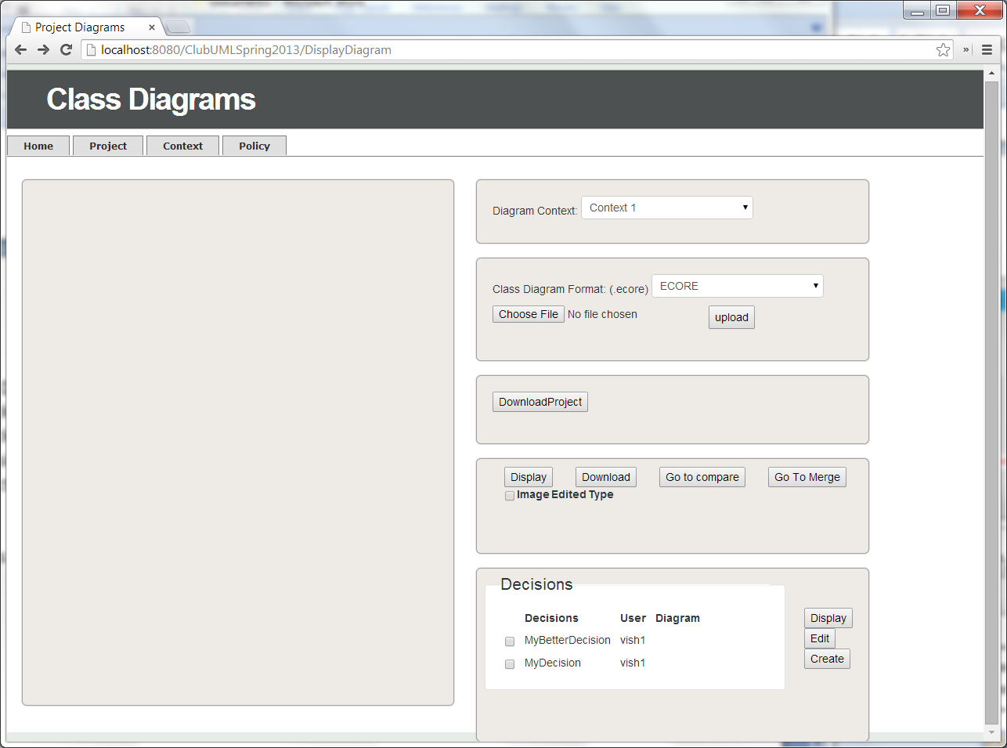

**Use-Case Diagrams**

1) Adding Use-Case Diagram

a) Click on the "Projects" tab

b) Click on the "Use Case App" button

c) Click on "Chose File" button to add Use Case XML file

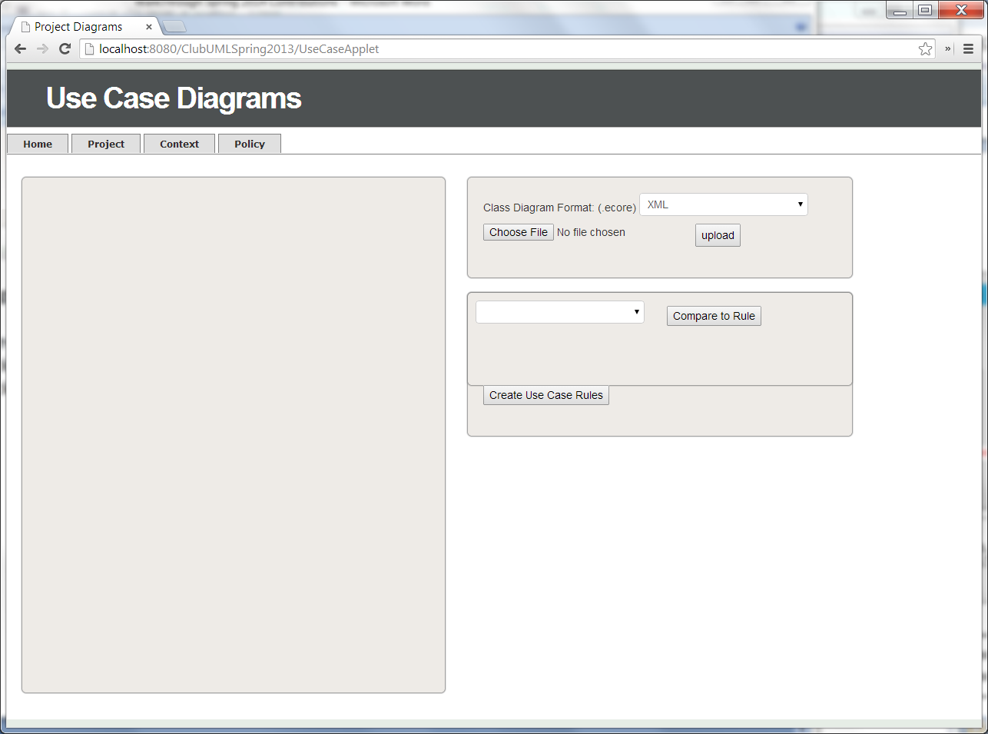

d) For Test File, select <ClubUML Locaiton>\UseCaseTestFiles\testnew.xml

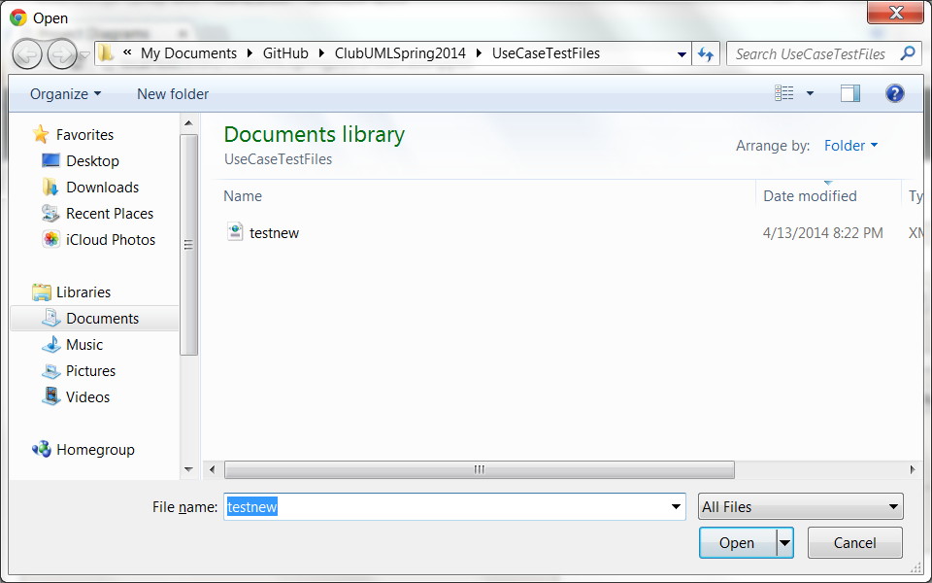

e) Click the "Upload" button [At this point, if it was successful, the portion right below will list the particular file name in the drop-down menu.]

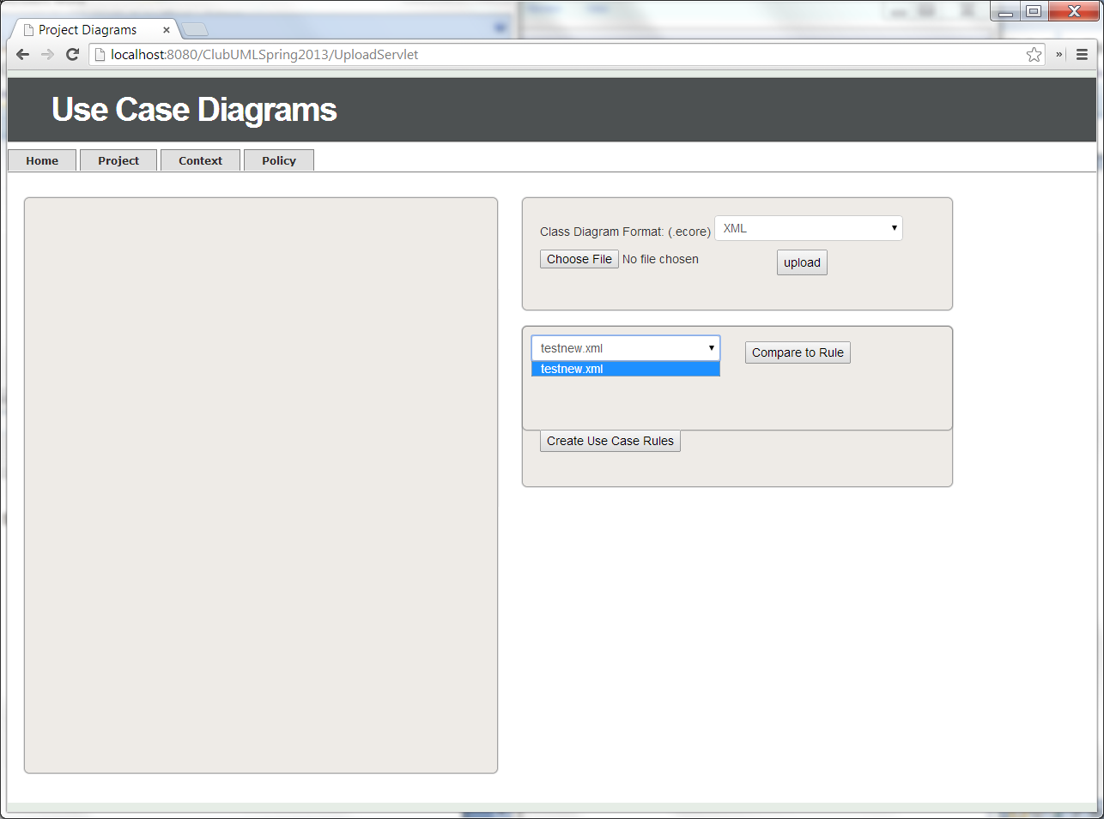

2) Create Use-Case Rules

a) Click on the "Projects" tab

b) Click on the "Use Case App" button

c) Click on the "Create Use Case Rules"

d) Add various Rules, via buttons, "Add Actor", "Add Use Case", Must-have Association's "Add Association", Must-not-have Associations "Add Associations", Must-have Inclusions/Extensions "Add Inclusion/Extension", and Must-not-have Inclusions/Extensions "Add Inclusion/Extension"

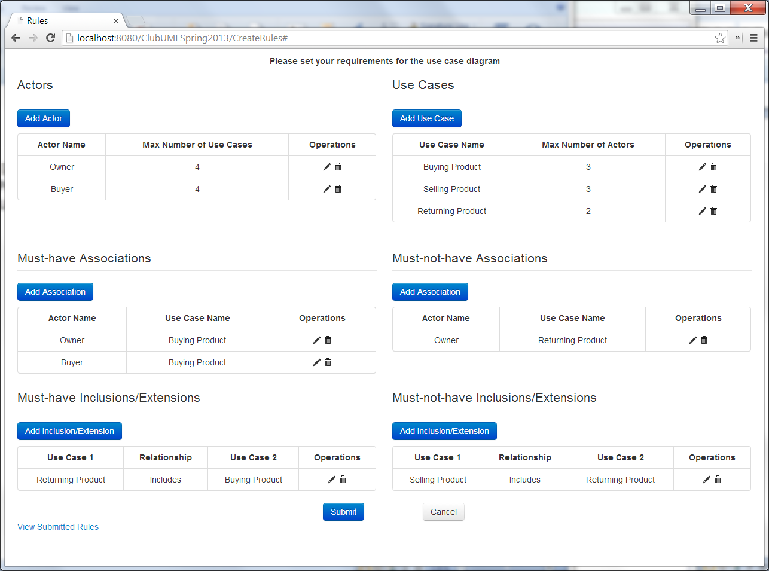

e) Click on the "Submit" button

3) View Use-Case Rules

a) Click on the "Projects" tab

b) Click on the "Use Case App" button

c) Click on the "Create Use Case Rules"

d) Click on the "View Submitted Rules" hyperlink. [At this point the rule create will be displayed.]

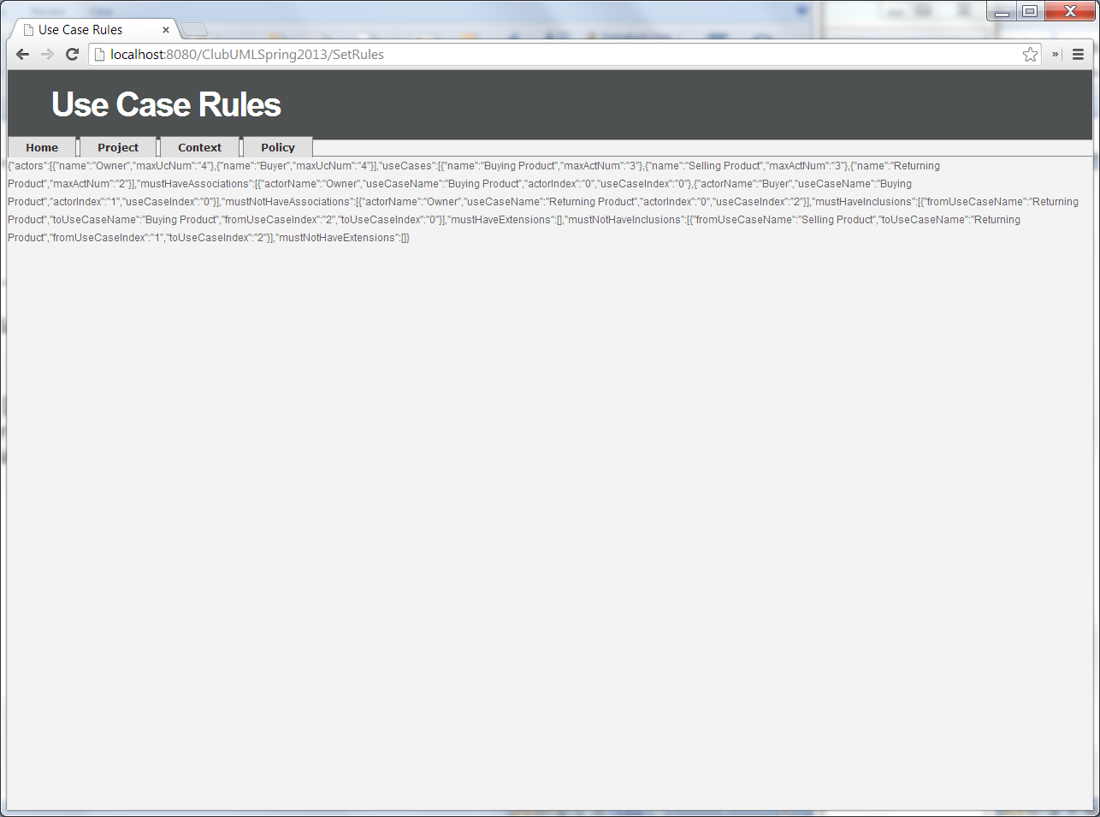

4) Compare Use-Case Diagram Against Use-Case Rule

a) Click on the "Projects" tab

b) Click on the "Use Case App" button

c) Select the Use Case File

d) Click on the "Compare to Rule" button [At this point comparison results will be displayed.]

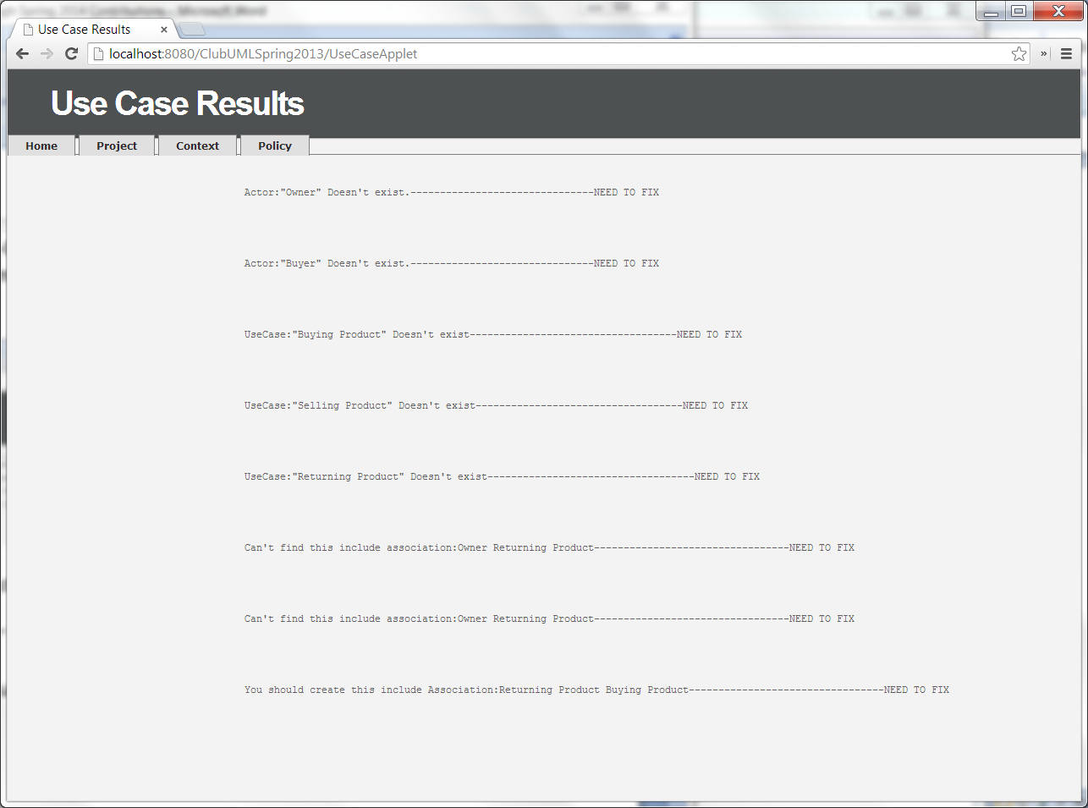

**Bug-Fixes**

**Validation**